S.A. ENGINEERING

COLLEGE

(Autonomous – Institute Level Research Centre, Affiliated to Anna University, Chennai) Accredited by NAAC ‘A’ Grade & ISO 9001:2015 Certified Institution

SUBJECT CODE: CS3202

SUBJECT TITLE: ESSENTIALS AND PRACTICES OF

SOFTWARE DEVELOPMENT (lab integrated)

PROJECT TITLE: SURVEY FORM

PRESENTED BY:

MOGHIT KUMAR S - 111924CS01157

SATYA PRIYAN R - 111924CS01241

LOGESH J - 111924CS01136

SUBMISSION DATE:

**INDEX**

|  |  |  |
| --- | --- | --- |
| **S.NO** | **CONTENT** | **PAGE NO.** |
| 1. | INTRODUCTION | 01 |
| 2. | BENEFITS | 02 |
| 3. | HARDWARE AND SOFTWARE COMPONENTS | 03 |
| 4. | FLOW DIAGRAM | 05 |
| 5. | MODULES | 06 |
| 6. | SOURCE CODE | 07 |
| 7. | FUTURE ENHANCEMENT | 15 |
| 8. | SAMPLE INPUT | 16 |
| 9. | RESULT | 17 |

**PROJECT:** SURVEY FORM

# INTRODUCTION:

# Thank you for taking the time to participate in this survey. Your feedback is incredibly important to us and will directly contribute to [insert purpose – e.g., improving our services, enhancing your experience, shaping future decisions, etc.].

# The purpose of this survey is to understand your views, preferences, and experiences so we can make more informed and meaningful improvements. We aim to create better solutions, and your insights are essential in helping us do that.

# This survey will take approximately [X minutes] to complete. Your responses are completely confidential and will be used solely for research and analysis. Please feel free to be open and honest—there are no right or wrong answers.

# Participation is voluntary, but your voice matters. Every response helps us get a clearer picture and move forward in the right direction. We truly value your time and effort in helping us grow and serve you better.

# Thank you again for your support and input.

# BENEFITS:

* **Gathers Valuable Feedback**

**:**Surveys allow you to collect honest opinions, experiences, and suggestions from your target audience. This feedback helps in making informed decisions.

* **Identifies Strengths and Weaknesses**

:They help highlight what’s working well and where improvements are needed—whether it’s a product, service, or process.

* **Enhances Customer Satisfaction**

:Understanding customer or user needs through surveys enables better service, leading to higher satisfaction and loyalty.

# HARDWARE AND SOFTWARE COMPONENTS:

## Hardware Requirements:

Any device with internet access (PC, tablet, smartphone).

## Software Requirements:

Web browser (Chrome, Firefox, Safari, etc.).

Basic HTML, CSS, and JavaScript knowledge for further customization.

## Technologies Used:

* 1. HTML for structure.
  2. CSS for styling.
  3. JavaScript for interactive elements.

# FLOW DIAGRAM:

## STEPS:

* + - Create the survey
    - Share the survey.
    - Collect the responses
    - Analyze Results

# MODULES:

* + - **Input Module:** Handles user input for subject
    - **Calculation Module:** Processes the input to calculate total and average scores.
    - **Output Module:** Displays the results to the user.
    - **Validation Module:** Ensures that the input is valid and provides error messages if necessary.

# SOURCE CODE:

* + - * Provide snippets of the HTML, CSS, and JavaScript code used in the project.
      * **HTML:** Structure of the form and layout.
      * **CSS:** Styling for a visually appealing interface.
      * **JavaScript:** Logic for calculating grades and displaying results.
      * Highlight key functions and their purposes

|  |
| --- |
| <!DOCTYPE html> |
| <html lang="en"> |
| <head> |
| <meta charset="UTF-8"> |
| <meta name="viewport" content="width=device- width, initial-scale=1.0"> |
| <title>Student Grade Calculator</title> |

|  |
| --- |
| <style> |
| body { |
| font-family: 'Arial', sans-serif; |
| background: linear-gradient(135deg, #74d3ae, #89c1f9); |
| margin: 0; |
| padding: 0; |
| display: flex; |
| justify-content: center; |
| align-items: center; |
| height: 100vh; |
| flex-direction: column; |
| color: #333; |
| } |
| .container, .about-us { |
| background: #fff; |
| padding: 25px; |
| border-radius: 15px; |
| box-shadow: 0 8px 15px rgba(0, 0, 0, 0.2); |
| width: 350px; |
| margin-bottom: 20px; |
| transition: transform 0.2s, box-shadow 0.2s; |
| } |

|  |
| --- |
| .container:hover, .about-us:hover { |
| transform: scale(1.05); |
| box-shadow: 0 12px 20px rgba(0, 0, 0, 0.3); |
| } |
| h1, h2 { |
| text-align: center; |
| font-size: 26px; |
| color: #222; |
| margin-bottom: 15px; |
| text-transform: uppercase; |
| letter-spacing: 1px; |
| } |
| .about-us { |
| background: linear-gradient(135deg, #f9d423, #ff4e50); |
| color: #fff; |
| padding: 20px; |
| border-radius: 10px; |
| box-shadow: 0 5px 10px rgba(0, 0, 0, 0.15); |
| text-align: center; |
| margin-bottom: 20px; |

|  |
| --- |
| } |
| .about-us p { |
| font-size: 14px; |
| line-height: 1.6; |
| } |
| .input-field { |
| margin-bottom: 15px; |
| } |
| label { |
| display: block; |
| margin-bottom: 5px; |
| color: #555; |
| font-size: 14px; |
| font-weight: bold; |
| } |
| input[type="number"] { |
| width: 100%; |
| padding: 10px; |
| border: 1px solid #ccc; |
| border-radius: 8px; |

|  |
| --- |
| box-shadow: inset 0 2px 4px rgba(0, 0, 0, 0.1); |
| } |
| button { |
| width: 100%; |
| padding: 12px; |
| background: linear-gradient(135deg, #4CAF50, #45a049); |
| color: white; |
| border: none; |
| border-radius: 8px; |
| cursor: pointer; |
| font-weight: bold; |
| text-transform: uppercase; |
| letter-spacing: 1px; |
| transition: background 0.3s, transform 0.3s; |
| } |
| button:hover { |
| background: linear-gradient(135deg, #45a049, #4CAF50); |
| transform: translateY(-2px); |
| box-shadow: 0 5px 10px rgba(0, 0, 0, 0.2); |
| } |

|  |
| --- |
| .result { |
| margin-top: 20px; |
| text-align: center; |
| font-size: 16px; |
| color: #444; |
| } |
| .result p { |
| margin: 8px 0; |
| } |
| </style> |
| </head> |
| <body> |
| <div class="about-us"> |
| <h2>About Us</h2> |
| <p>We’re passionate about crafting tools to make learning simple, efficient, and fun. This interactive grade calculator is here to help students track their academic progress with ease.</p> |
| </div> |
| <div class="container"> |
| <h1>Grade Calculator</h1> |
| <form id="gradeForm"> |

|  |
| --- |
| <div class="input-field"> |
| <label for="subject1">Subject 1 Score</label> |
| <input type="number" id="subject1" required> |
| </div> |
| <div class="input-field"> |
| <label for="subject2">Subject 2 Score</label> |
| <input type="number" id="subject2" required> |
| </div> |
| <div class="input-field"> |
| <label for="subject3">Subject 3 Score</label> |
| <input type="number" id="subject3" required> |
| </div> |
| <div class="input-field"> |
| <label for="subject4">Subject 4 Score</label> |
| <input type="number" id="subject4" required> |
| </div> |
| <div class="input-field"> |
| <label for="subject5">Subject 5 Score</label> |
| <input type="number" id="subject5" required> |
| </div> |
| <button type="button" onclick="calculateGrade()">Calculate</button> |
| </form> |
| <div class="result" id="result"></div> |

|  |
| --- |
| </div> |
| <script> |
| function calculateGrade() { |
| const subject1 = parseFloat(document.getElementById('subject1'). value); |
| const subject2 = parseFloat(document.getElementById('subject2'). value); |
| const subject3 = parseFloat(document.getElementById('subject3'). value); |
| const subject4 = parseFloat(document.getElementById('subject4'). value); |
| const subject5 = parseFloat(document.getElementById('subject5'). value); |
| if ( |
| !isNaN(subject1) && |
| !isNaN(subject2) && |
| !isNaN(subject3) && |
| !isNaN(subject4) && |

|  |
| --- |
| !isNaN(subject5) |
| ) { |
| const total = subject1 + subject2 + subject3 + subject4 + subject5; |
| const average = total / 5; |
| document.getElementById('result').innerHTML =  ` |
| <p><strong>Total:</strong> ${total}</p> |
| <p><strong>Average:</strong>  ${average.toFixed(2)}</p> |
| `; |
| } else { |
| document.getElementById('result').innerText = 'Please enter valid scores for all subjects.'; |
| } |
| } |
| </script> |
| </body> |
| </html> |

# FUTURE ENHANCEMENT:

## Additional Features:

*Option to save results for future reference.

Ability to calculate grades for different grading systems (e.g., letter grades).

*Mobile app version for offline access.

\***User Feedback Integration:** Implementing user suggestions for improvements.

\***Data Visualization:** Graphs and charts to represent academic performance over time.

**SAMPLE INPUT:**

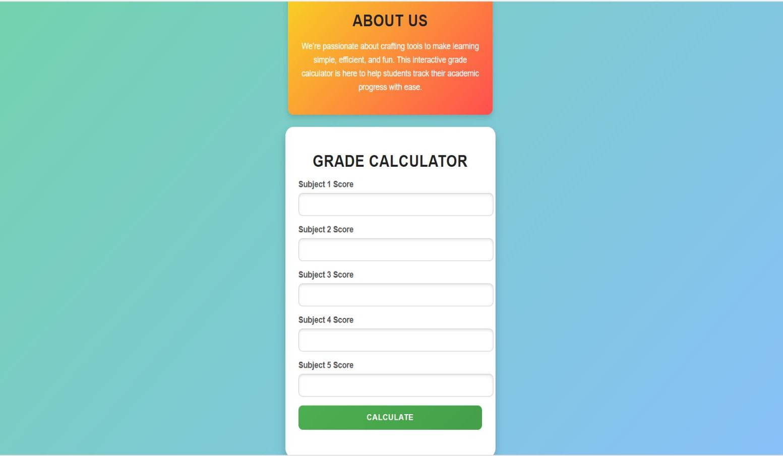**SAMPLE OUTPUT:**

**C:\Users\DELL\Pictures\Screenshot 2025-04-06 035059.png**

**RESULT:**

The Student Grade Calculator provides instant results as soon as the user inputs their scores and clicks the "Calculate" button.

This immediate feedback is crucial for several reasons: **Quick Assessment:** Students can quickly assess their performance without waiting for manual calculations or feedback from teachers.

**Encouragement for Improvement:** By seeing their total and average scores right away, students can identify areas where they excel and where they may need to focus more effort.

**Motivation:** Instant results can motivate students to strive for better grades, as they can see the direct impact of their efforts.

**SIGNATURE OF THE FACULTY**